Issue: Needed to add a button to increase or decrease the size of the video at will on a button click event. Alignment also conflicted with the existing video iframe & the new buttons needed to be re-centered. scrum

Main Solution (...to make visible):
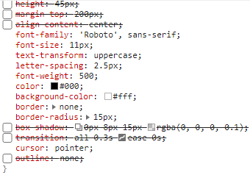

Sources:

https://www.w3schools.com/csS/css3_buttons.asp
https://www.geeksforgeeks.org/how-to-get-the-id-of-the-clicked-button-using-javascript-jquery/
https://developer.mozilla.org/en-US/docs/Web/CSS/CSS_Box_Alignment/Box_Alignment_In_Block_Abspos_Tables
https://developer.mozilla.org/en-US/docs/Web/CSS/align-content
https://webplatform.github.io/docs/tutorials/manipulating_css_with_javascript/

**Liu Siyan’s BG color implementation also works...

